GRADE 11
MEMO
November Exam
HISTORY
3 Hours 200 marks
NAME:………………………………………………… KEY:……..
EXAMINER: MR. D EDWARDS
MODERATOR: MRS. J MOGG
INSTRUCTIONS:
This paper consists of 9 pages, excluding the cover page.
The source booklet consists of 6 pages, excluding the cover page.
You are to answer all questions in the exam booklet provided.
Start each section on a new page.
Make sure your answers are clearly written.
Time yourself and do not spend too much time on one question and too little on another.
The exam paper consists of 3 sections:
Section 1 – Single Source Analysis /60
Section 2 – Multiple Source Questions /90
Section 3 – Source Based Essay /50
TOTAL: /200

SECTION 1 – SINGLE SOURCE ANALYSIS
SOURCE 1

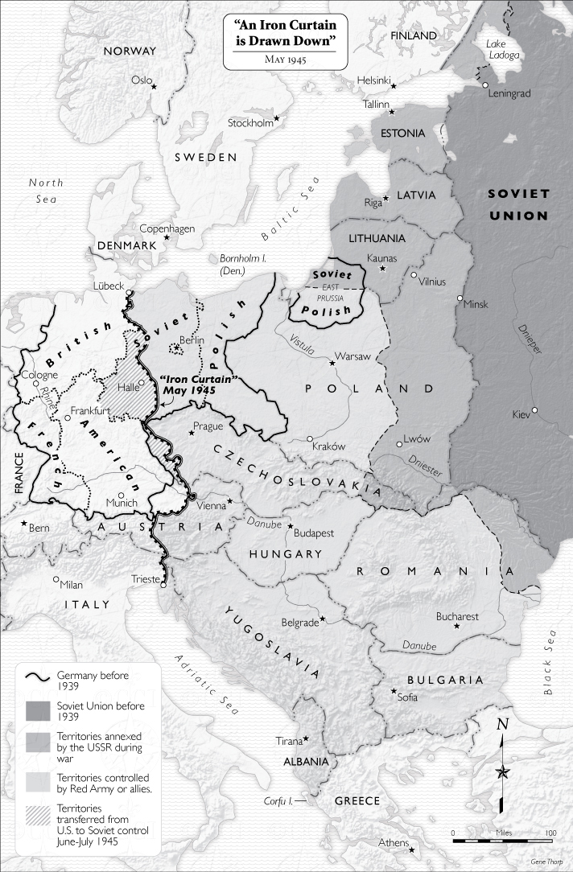

1. 1. The Iron Curtain was not literally a curtain of iron. What was it and why do you think it was a suitable name? (6)

Collection of Soviet Friendly Countries (Not exclusively Satellite States) that separated the West from the East, and by extension, capitalism from communism.
Yes it was appropriate,
Curtains (in the theatre) fall quickly and steadily, just like the Satellite fall to communism quickly and steadily.
Iron is impenetrable, can't get through it, similar to the Soviet friendly countries.
A curtain blocks all view of what is behind it, separating the stage from the audience. The Soviet friendly countries did just this with capitalism and communism.

1. 2. What was the economic and political difference between the countries in the west and the countries in the east? (4)

West - Capitalism
East - Communism

1. 3. Explain the difference between land annexed by the Soviet Union, and other countries where Soviet communism was imposed. (4)

Annexed land was land taken on by the USSR, in order to strengthen it. These countries became provinces/areas of the USSR.
Countries where Soviet Communism was imposed maintained the independence. They were intended to support the USSr by being political, economical and ideological partners.

1. 4. Yugoslavia had adopted a communist system, but differed from other communist countries. How can you tell this from the map? (2)

It is a collection of many Soviet nations.
Access to the Mediterranean.

1. 5. Suggest reasons why Stalin insisted that East Prussia, which had been part of Germany, was incorporated into either Poland or the USSR. (4)

USSR did not want Capitalist influence within Soviet territory, being part of Poland, USSR friendly, or USSR would ensure the sphere of influence was infiltrated.
East Prussia gives the USSR access to the sea in the north further South, this is important because Northern Sea freezes over in winter.
USSR had liberated East Prussia from the Germans and felt it right that they receive the land as a reward.

(20)

SOURCE 2
“As your President, I pledge that I shall always uphold that proud bipartisan tradition. Standing in this Convention Hall 4 years ago, I pledged to seek an honorable end to the war in Vietnam. We have made great progress toward that end. We have brought over half a million men home, and more will be coming home. We have ended America's ground combat role. No draftees are being sent to Vietnam. We have reduced our casualties by 98 percent. We have gone the extra mile, in fact we have gone tens of thousands of miles trying to seek a negotiated settlement of the war. We have offered a cease-fire, a total withdrawal of all American forces, an exchange of all prisoners of war, internationally supervised free elections with the Communists participating in the elections and in the supervision.

There are three things, however, that we have not and that we will not offer. We will never abandon our prisoners of war. Second, we will not join our enemies in imposing a Communist government on our allies - the 17 million people of South Vietnam. And we will never stain the honor of the United States of America.”

R. Nixon speech to Republican National Convention, Aug. 23, 1972.

2. 1. What measures has the USA gone to in their attempts to negotiate a settlement of the war? (4)

America have offered a cease-fire, a total withdrawal of all American forces, exchange of POW, free elections.

2. 2. Define the term ‘Vietnamisation’. (3)

The US policy of withdrawing its troops and transferring the responsibility and direction of the war effort to the government of South Vietnam.

2. 3. Why does President Nixon state, “there are three things, however, that we have not and that we will not offer”? Explain with reference to your own knowledge. (4)

America had put in place the policy of containment, which stated they they must prevent communism spreading wherever it goes.
America believed in the domino theory, if one country falls to communism all of the surrounding countries will.
This meant that America could not simply withdraw and lose the war, as it went against its own policies it created. It would seem hypocritical and against American values, which is the moral code they hold over the USSR.

2. 4. Why is it significant that no draftees are being sent to Vietnam? Justify your answer in full. (4)

It means that Nixon is not sending anyone else to Vietnam, and thus slowing pulling out of the war. This was important as their were anti war rallies, draft dodges and opposition to the draft among students. People will be happy that young men are not being being sent to the war.

2. 5. Would you consider this source to be reliable for a Historian studying the Vietnam War? Explain your answer. (5)

No. Nixon is up for reelection in 1973, this speech is an attempt to win votes, this shows the hidden agenda.
It is bias towards himself and the work America has done in limiting the influence over Vietnam, this is intended to manipulate the population into voting for him.
It is exaggerated and contains propaganda - Pro American sentiment and only focusing on positive facts about Vietnamisation.
Leaves out vital information about the ARVN and how they hope to win the war, it leaves out why the offers for peace have been refused.

(20)

SOURCE 3
“Like I said, I really don’t have a memory of getting engaged in it that much. I remember conversations about McCarthy, and McCarthyism, and Communism, and some degree of understanding of what he had done to other people’s lives. But we weren’t really a political family. We really didn’t get into the discussions about any of this. It was more about being concerned about whether you were going to be drafted or whether you should enlist rather than the geo-political situation. I had a choice. I mean I didn’t have a choice. You’re going to get drafted. So either you’re going to get drafted or you’re going to choose a path. I had pretty high battery test scores. So I went to the Navy. They actually wanted me to sign me up for an additional two years to go into nuclear. I said, “You have four years. I’ll be glad to go but I’m not giving you two more years of my life.” That much I knew. I was pretty strong about. If I had a choice, I didn’t want to go. I don’t think I had any. There was no sense of duty to the country. It was more like an obligation that I have to go and do this thing. It’s like most vets. They really don’t want to talk about it generally.
This is what it is for vets. This is why they’re homeless, generally. I’m convinced of this. We want to go home. Home is what I grew up with honesty, integrity, a sense of principals, and so forth. And these conflicts are not. And you come out the other side and you try to go back home and you can’t. You try to address that and you can’t. I can’t go home now. I tried to talk to my family and my sister and I don’t even talk anymore. Because I can’t let go of this until there is justice. I was part of a war machine that slaughtered five-million people, which seems like such a stupid thing to say. I mean, I can’t wrap my head around that. When you melt it down to a child and a mother and then they’re gone, they’re in a field and then they’re gone. And that means nothing to us? Even today that means nothing to us.“
An interview conducted in February 2012 with American Vietnam War Veteran Joseph LaBonte. Joseph was drafted in 1968 and worked on an aircraft carrier from 1969-1972. He explains his anger after the war and his personal journey in dealing with resentment.

3. 1. Define the historical term ‘Communism’. (2)

A political theory derived from Karl Marx, advocating class war and leading to a society in which all property is publicly owned and each person works and is paid according to their abilities and needs.

3. 2. Why were young people in America concerned with the draft? (2)

Meant they had to go to Vietnam to fight and they did not have a choice.

3. 3. According to La Bonte, did most people feel proud to be going to the Vietnam War? Explain your answer with reference to the source. (3)

No, many people were not concerned with the political nature of Vietnam, it was not a choice for them. “You either got drafted or you chose a path.”

3. 4. What impression of the Vietnam War does La Bonte provide? Provide 3 quotes when justifying your answer. (6)

Terrible, horrid, obligation, etc.
Any 3 quotes that present the above impression + explanation how quote does this.

3. 5. Is La Bonte in support of America’s involvement in the Vietnam War? Justify your answer in full. (4)

No.
He indicates he was part of a war machine. This is a negative connotation as a war machines only job is to cause destruction.
America killed innocent people, mothers and children. He can’t wrap his head around it, showing that he doesn't agree with the intervention as he can't understand it.
He says that America doesn't care, even today. This shows that he doesn't think involvement was good as America shows no remorse for the actions.

3. 6. Is this source useful to a Historian studying the Vietnam War? Explain your answer with reference to the source. (3)

Yes.
Shows Veterans perspective on vietnam, they didn't like it, angry, bitter, america doesn't care.
Shows work done in the navy.
Shows the lack of choice to do with the draft system.
Any other logical answer.
(20)
[TOTAL: 60]
SECTION 2 – SOURCE BASED QUESTIONS
Explain the following historical concepts:
1. Détente (2)
The easing of hostility or strained relations, especially between countries.
2. Policy of Containment (2)
America’s intention to stop the spread of communism throughout the world
3. Socialism (2)
A political and economic theory of social organization that advocates that the means of production, distribution, and exchange should be owned or regulated by the community as a whole.
Refer to Source A
4. List 4 things that the ‘Truman Doctrine’ is against. (4)
Hunger
Poverty
Desperation
Chaos
5. Why does General George C. Marshall think the “world situation is very serious”? (3)
Europe has suffered badly
They cannot, for the next 3-4 year, pay for what they need
If they don’t get what they need, food and essential products, they will face economic, social and political deterioration.
Refer to Source B
6. Provide one visual clue that America is being altruistic (showing a disinterested and selfless concern for the well-being of others). (2)
Uncle Sam is carrying bags of American Dollars in bags to other parts of the world.
7. Does the cartoonist agree with the Marshall Plan? Explain your answer with reference to the source. (4)
No, he feels that the Marshall Plan is only looking after those outside of America. The cartoonist feels that American people should not suffer simply because the government is more concerned with what is happening outside its borders. This can be seen by the women in rags (poor clothes), she is saying Uncle Sam is too good (implying that he is being neglectful of American people in an effort to be helpful to other nations).
Refer to Source A and B
8. How do Sources A and B send the same message? Make reference to the source when justifying your answer. (4)
Source A says America has an obligation to help other countries “she must have substantial economic help” “Logical America should do all it can to help”.
Source B shows America doing all it can to help, carrying bags of money.
Both sources show America as a saviour to the rest of the world, specifically in altruistic way.
Refer to Source C
Answer the following questions with True or False as your answer.
9.1. Marshall Aid was motivated by only self-interest on America’s part. (2)
False
9.2. Truman was motivated by the Hitler’s aggression in 1930s when setting up the Marshall Plan. (2)
False
9.3. Marshall Aid was intended to create wealthy countries that could export their good to America. (2)
True
9.4. Stalin felt Marshall Aid was America’s attempt to control countries by making them dependant on trade and American skills. (2)
True
9.5. Stalin was optimistic and positive about the Marshall Aid at its inception. (2)
False

Refer to Source D
10. Does Andrei Vyshinsky think the Truman Doctrine and the Marshall Plan are positive/good strategies? Provide evidence from the source to substantiate your answer. (4)
No, says the Marshall Plan violates the UN, this shows he considers it bad because the UN is a peaceful organisation that would be perceived to have a good moral code.
US violating international collaboration + explanation.
Europe will be under US control because of the Marshall Plan + explanation.
Any other logical answer.
Refer to Source A and D
11. Why do the interpretations of the Truman Doctrine and the Marshall Plan differ in Source A and Source D? (4)
Source A said by Marshall, American, in charge of Plan, bias towards it. Will only see it as a good thing. Student must use evidence from the source to justify.
Source D said by Vyshensky, Russian, dislikes America, bias against them. Will only see bad side of Marshall Plan. Student must use evidence from the source to justify.
Refer to Source F
Answer the following questions with True or False as your answer.
12.1. The Marshall Plan was offered to all countries under communist threat. (2)
True
12.2. Sixteen countries were given $13,150,000,000 each to help rebuild. (2)
True
12.3. The Soviet Union considered taking Marshall Aid before July 1947. (2)
True
12.4. The Berlin Conference was where Molotov rejected the Marshall Plan. (2)
False
12.5. Hungary, Poland and Czechoslovakia took aid from the Marshall Plan despite disapproval from the USSR. (2)
False
Refer to Source E and G
13. What is the cartoonist’s (Source E) opinion of the Marshall Plan? Provide evidence from the source to justify your answer. (4)
It is bad, dishonest.
Poison in glasses. Poison is bad for you and will kill you, the cartoonist is saying that Marshall Aid will kill all those who take it.
Encouraging guests to drink it + explanation.
Children at the table + explanation.
14. What can we learn about President Truman from Source G? (3)
He believes in Freedom of choice.
He thinks all people should choose their own destiny.
He believes that it is America’s responsibility to set people free.
Any other logical answer.
15. How do Sources E and G differ in their message? Refer to the sources to substantiate your answer. (4)
Source E says America are bad, they want to dictate to other countries how they should run. Marshall Plan is being forced on them, big cowboy, scared faces, no choice to leave the table.
Source G says America are good and allow for freedom, choice and countries being allowed to do what they like. Provide quote.
These messages differ as they show America in two completely different lights, one positive and the protector of freedom, the other negative and the deliverer of poisonous policies.
Refer to Source H and I
16. How is America portrayed in Source H? Provide a quote to substantiate your answer. (3)
As heroes and saviours, “Humanitarians”.
17. Who does the author of Source I feel is to blame for the Berlin Crisis? Justify your answer with one quote from the source. (2)
America, “Self Blockade”
18. How and why do these sources differ in their interpretation of America’s actions? (8)
How -
Source H says America is an humanitarian, a saviour and that what they did was for the better of all people + example from source
Source I says America put their own people through suffering to try blame the USSR, they did a self blockade which caused people to freeze.
Source I sows America as altruistic heroes to the world which is very different to the Source H which shows them willing to sacrifice their own people simply to try put the USSR down.
Why -
American Newspaper, so biased towards them as a form of propaganda.
Cuba has become communist thus needs to show strength and success of Marshall Aid to temper fear of communism so close to home.
Berlin Wall built to separate ideology and people, Marshall Aid responsible for this as West Berlin far more successful than East Berlin. America want to show off so to speak.
Russian comment, will be biased towards Russia as a justification for the failed Berlin Blockade.
Berlin Blockade has been unsuccessful by the USSR, but by blaming America (saying they did it to themselves it gives the USSR an opportunity to save face with their own people.
19. Which source do you consider to be more reliable? Justify your answer with reference to both sources. (5)
Either source answer is acceptable. Student must justify with reference to both sources.
Refer to Source J
20. Explain the phrase, “Who’s next to be liberated from Freedom, Comrade?” (3)
“Which country will be set free next, friend.” The phrase means that Stalin is looking for another country to shift from capitalism to communism, which in the eyes of the society would be liberating them.
21. Why is Stalin about to pull down France’s switch? Explain with reference to your own knowledge. (3)
France had a strong communist party in 1947, that did not win the election in 1947. However because of WW1 and WW2 people did not trust a capitalist government, and so the communist party was seen a real option. The switch is currently up indicating that they are capitalist, but Stalin is about to pull the switch down, seeing them move to communism.
22. Explain the message of the cartoon. (4)
The message is that many countries are on the brink of communism, and all Stalin has to do is flick the switch. The cartoonist is trying to say that Stalin and Molotov feel that all countries in the world have communism in them, they simply need to be ‘turned on’ using a switch. There are countries already under his control, indicated by the switches, and it seems easy for him to get more control, he just needs to flick the switch down. Molotov is spinning a globe and is going to randomly place his finger on it, indicating that any country could be next and thus all countries have this underlying communism in them. Marshall is looking over them as if to inspire them or guide them, as if the Marshall Plan is the inspiration for this activation of communism.
[TOTAL: 90]

SECTION 3 - SOURCE BASED ESSAY

Answer the following essay question.

“The Marshall Plan was a selfless intervention introduced by America with Europe’s best interest at heart”.
Discuss the validity of this statement using the sources as evidence.

A reminder:
- Make sure your essay’s introduction indicates the argument.
- Include a counter-argument.
- Use every source.
- Write a conclusion that sums up the entire essay.

Selfless and with best interest at heart | Not Selfless and without Europe at heart
A - Europe can’t pay for herself (for 3 or 4 years), America must help.  Logical that they do so.  Only when europe is back can the world tend towards peace and stability.  Marshall Aid not against any countries, only poverty, chaos, etc. | C - Agenda to Marshall Plan, open American markets. Help all to avoid another Great Depression.
B - Bags of money being sent to Europe.  Altruistic, Europe even comes before American people. | D - Marshall Plan goes against UN, imposing will on Europe, Economic and Political control, create monopoly on American good that will lead to another Great Depression in Europe.
F - large sum of money given $1315000000. No country excluded. No strings attached (which is why Russia were interested). Selfless and for Europe. | E - America controlling, Marshall Plan is poison, no choice by european countries, they will suffer.
G - Freedom, choice, Truman doesn't want to impose anything. Own destiny. | I - America willing to kill their own people to show Russia up, self blockade of people in West Berlin (In Europe)
H - Selfless, humanitarian (which is a word used for selfless and altruistic), experiment which may have failed (shows America as altruistic)
J - not relevant (but shows Stalin in a bad light, thus could possibly show America in a good light)

[TOTAL: 50]

